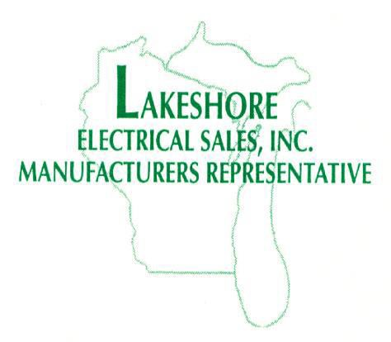**CONTACT US!**

Phone: 262.478.0680 OR

800.229.2227

Fax: 262.478.0595

Lakeshoreelectrical.net 6000 W Executive Drive

Suite A | Mequon, WI | 53092

**Please send orders to:** [**orders@lakeshoreelectrical.net**](mailto:orders@lakeshoreelectrical.net)



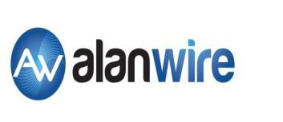



* B-LINE series
* WIRING DEVICES
* CROUSE-HINDS series
* EDISON series





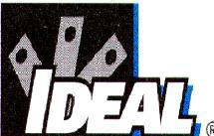



**Outside Sales**

Jerry Duwell – Principal (Milwaukee area) [jerry.duwell@lakeshoreelectrical.net](mailto:jerry.duwell@lakeshoreelectrical.net)

Jon Franklin – Principal (Fox Valley, UP) [jon.franklin@lakeshoreelectrical.net](mailto:jon.franklin@lakeshoreelectrical.net)

**Jay Longley** (Madison area/Northern WI)

[jay.longley@lakeshoreelectrical.net](mailto:jay.longley@lakeshoreelectrical.net)

**Allen Duwell** (Southeastern WI)

[allen.duwell@lakeshoreelectrical.net](mailto:allen.duwell@lakeshoreelectrical.net)

**Len Atkins** (Northern WI C-H specialist)

[len.atkins@lakeshoreelectrical.net](mailto:len.atkins@lakeshoreelectrical.net)

Heidi Ruiz (Southern WI C-H specialist)

heidi.ruiz@lakeshoreelectrical.net

**Inside Sales / Customer Service**

**Korene Sheridan** (B-line, HPS, Quazite, Intermatic)

[korene.sheridan@lakeshoreelectrical.net](mailto:korene.sheridan@lakeshoreelectrical.net)

**Kaylee Juhasz** (Crouse-Hinds, Edison, Interconnect, Wiring Devices, Penn-Union) [**kaylee.juhasz@lakeshoreelectrical.net**](mailto:kaylee.juhasz@lakeshoreelectrical.net)

**Amy Cook** (Alan Wire, Kaf-Tech, TF Kable, Wheatland)

[commodities@lakeshoreelectrical.net](mailto:commodities@lakeshoreelectrical.net)

Katherine Okray (Berko/Qmark, Cantex)

**katherine.okray@lakeshoreelectrical.net**

**Stephanie Burgardt** (EPCO, LH Dottie, Ideal, Rectorseal, GE)

[stephanie.burgardt@lakeshoreelectrical.net](mailto:stephanie.burgardt@lakeshoreelectrical.net)

Linda Walter

[linda.walter@lakeshoreelectrical.net](mailto:linda.walter@lakeshoreelectrical.net)